How to Register with Lakeview Community Association

Go to our website and Click on the REGISTRATION tab
From there it will take you the PROGRAMS page so you can see all the programs displayed by the day and time they are offered. **Please note that Soccer is listed on Sundays because the actual day and times are NOT known yet. Clicking the Blue Down Arrow to the right of the class will give you all the class information.

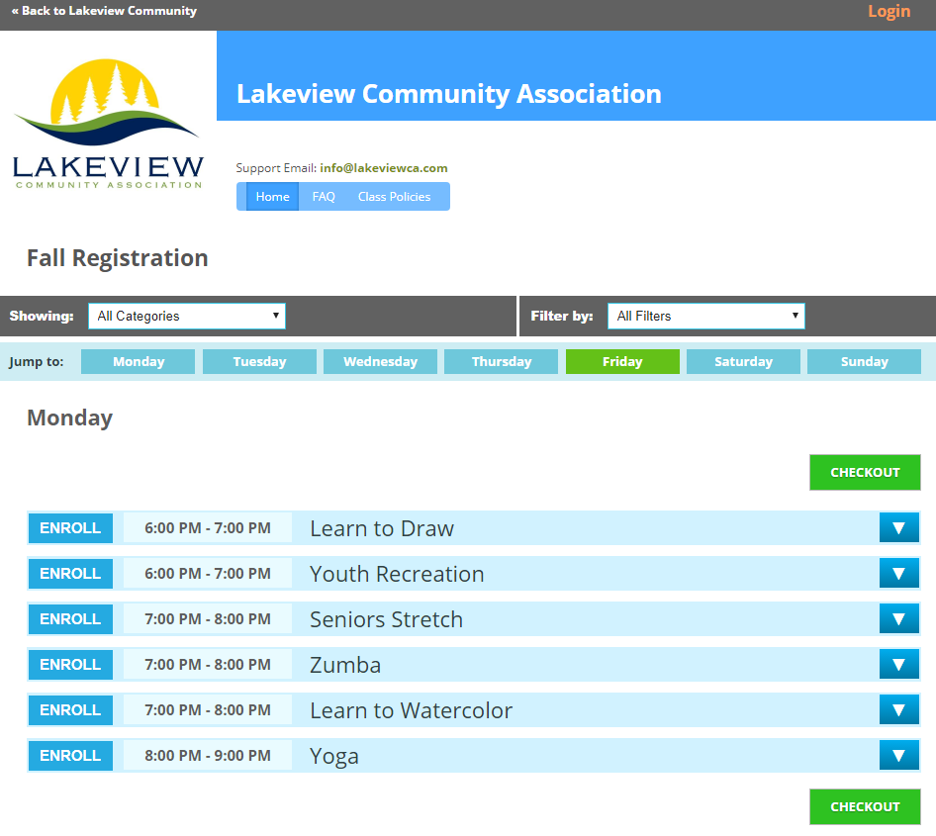

Once you see the program you would like to register for Click the ENROLL button. It will turn to an orange ADDED button. You can add all classes at this point that you (or your family members) want to enroll in. When you are done you can press CHECKOUT.
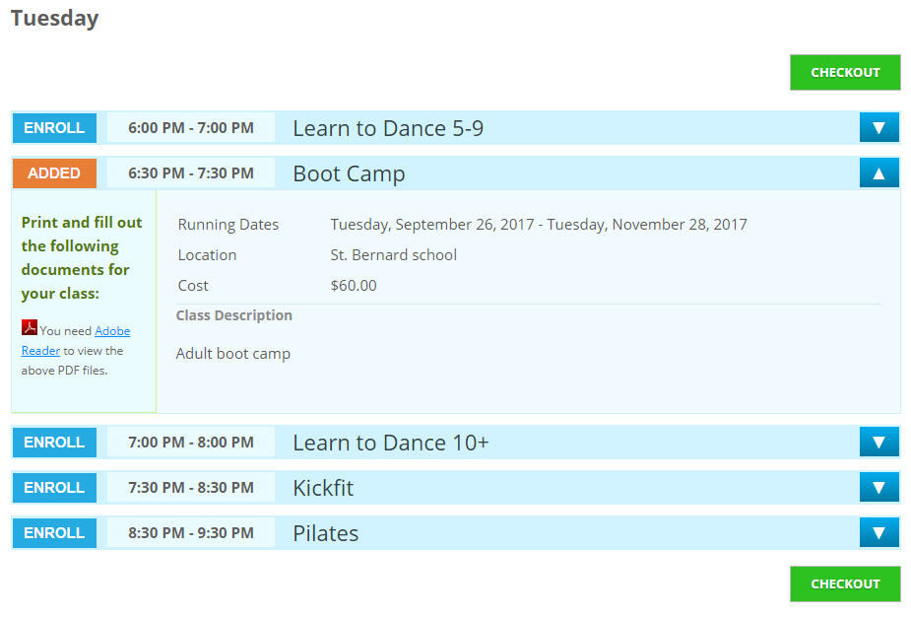

The “Step 1” page will appear and now you can enter your information to create your account. You can create ONE account for you and your family. See New Member.
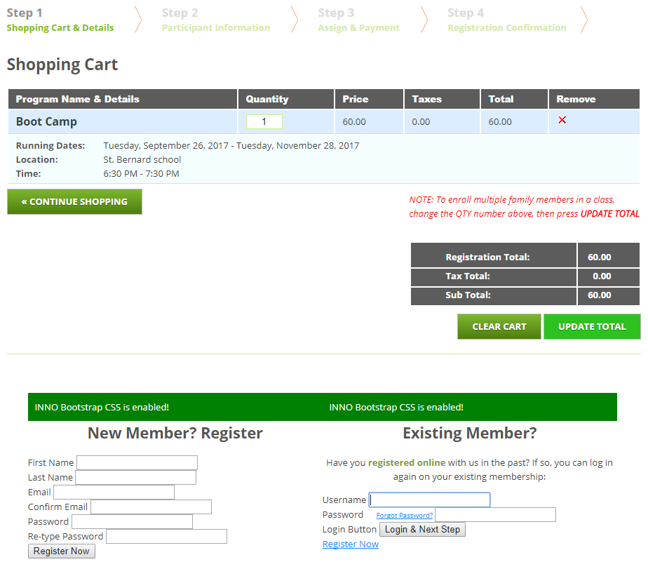

Fill out Step 2 for you and every member of your family. Later in Step 3 you will be able to select which one in your family is taking the class you have currently selected.
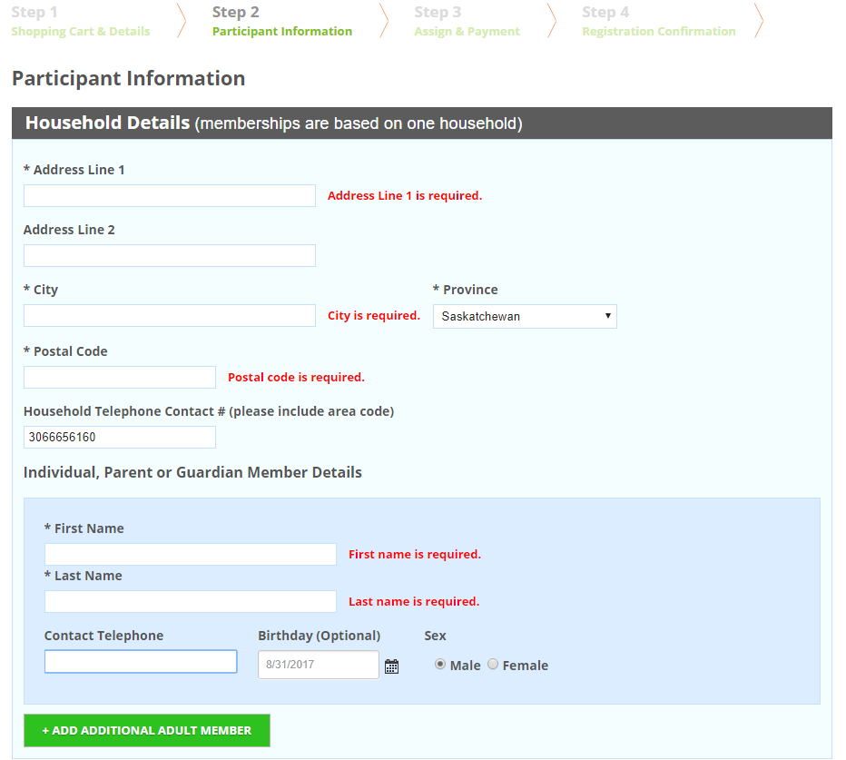
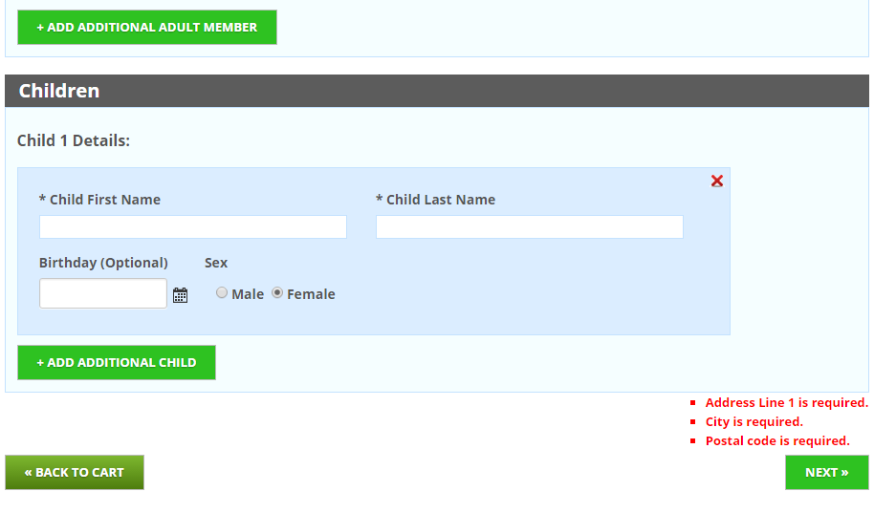

Step 3. A reminder that ALL new accounts will be charged per household the membership fee of $10. It is valid until Aug 31, 2018

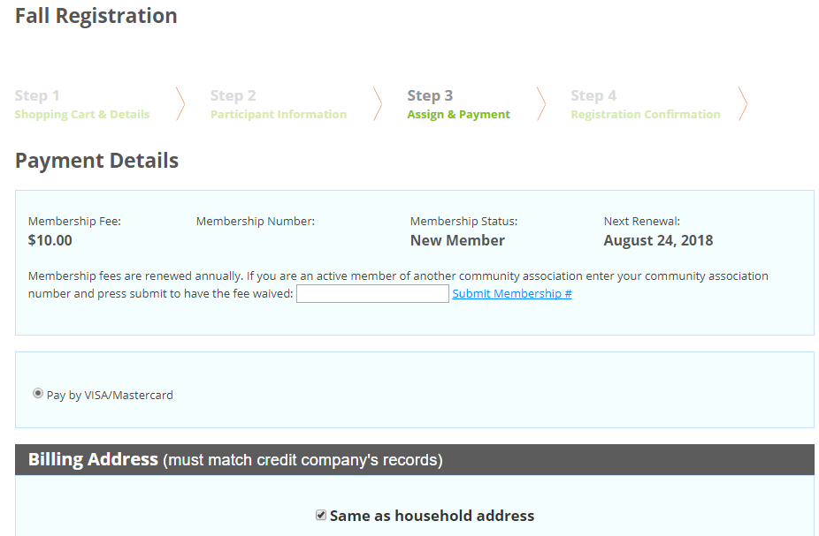

At the bottom of Step 3 is where you can select the member of your family for the class
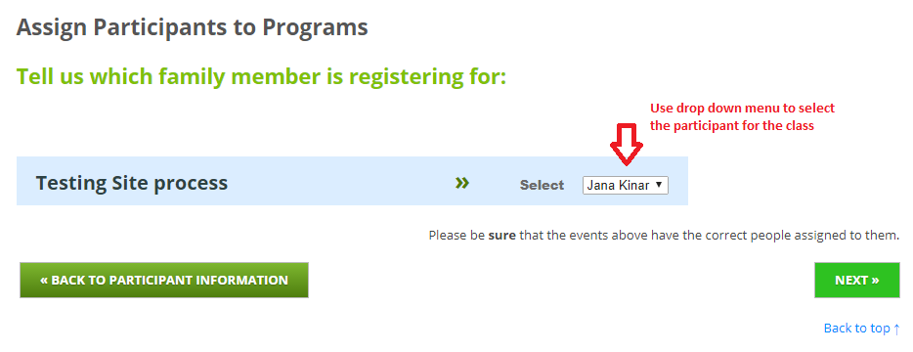

Step 4 is the Confirmation Page. Please review all the information and select CONFIRM PURCHASE. You will see a final confirmation window and a confirmation email should be sent to you as well.
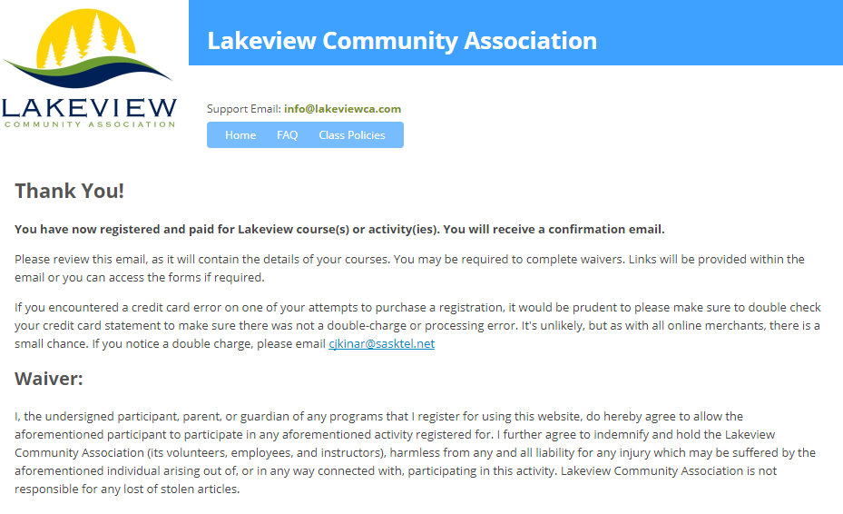

How to Register when you have already created an account:
Now that you have created the account you will be able to sign into the Home page of the registration page. After you have picked your class Step 1 will pop up. The continue button is not obvious however…its down low on the page. Everything else after this should be like the above instructions.
